**Services**

* Lawn Cutting
* Garden Planting
* Leaf Clearing (fall)
* Snow Shoveling (winter)

**Relation**

* Customer (1:M) Services
* Customer (repeat) Services
* Team (1:M) Services
* Team (M:1) Service
* Employee (1:1) Team
* OHIP (1:1) Employee
* Customer (M:M) Products
* Product (1:1) Classification
* Classification (1:M) Product

**User View 1:**

**Normalization**:

**UNF** (Invoice Number, Service Code→ Invoice Date, Work Team, Customer, Customer’s Address, Equipment Used, Description, Hourly Charge, Work Duration, Total Charge)

**1NF**

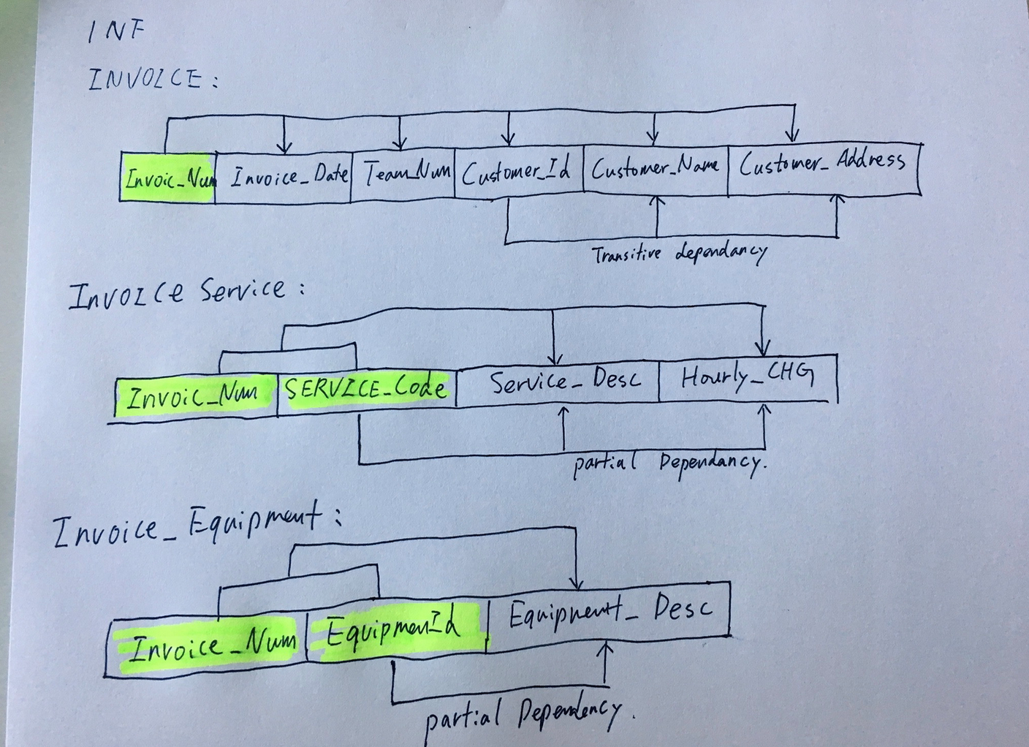

**Invoice:**Invoice_Number -> Invoice_date, Team_Num, Customer_Id, Customer_Name, Customer_Address.

**Invoice Service:**(Invoice Number, Service Code→ Service_Description, Hourly_Charges)

**Invoice Equipment:(**Invoice_Number,Equipment_Id->Equipment_Description

**Partial Dependencies:**

Service Code -> Service Description

Equipment_Id->Equipment_Description

**Transitive Dependencies:**

Customer_Id->Customer_Address, Customer_Name

**2NF**

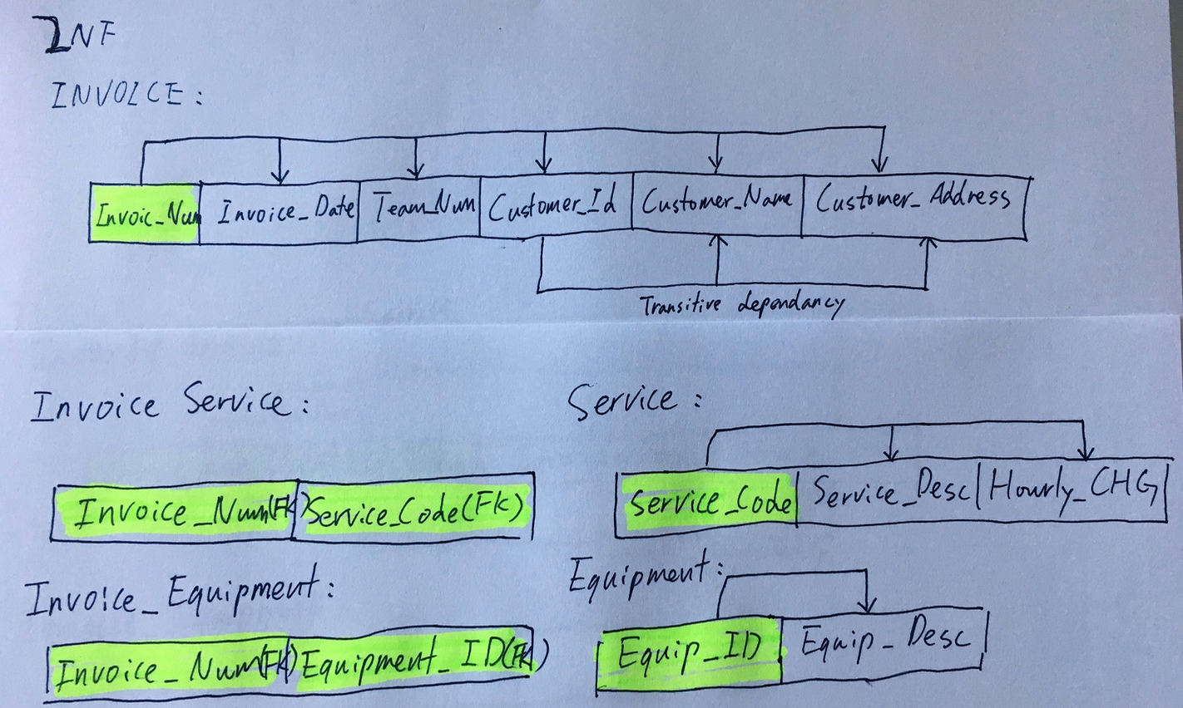

**Invoice:**Invoice_Number -> Invoice_date, Team_Num, Customer_Id, Customer_Name, Customer_Address.

**Invoice Service:**(Invoice Number, Service Code(FK)) **Service:(**Service_Code-> Service_Description**)**

**Invoice Equipment:(**Invoice_Number,Equipment_Id->Equipment_Description

**Equipment:**Equipment_Id -> Equipment_Description

**Transitive Dependencies:**

Customer_Id->Customer_Address, Customer_Name

**3NF**

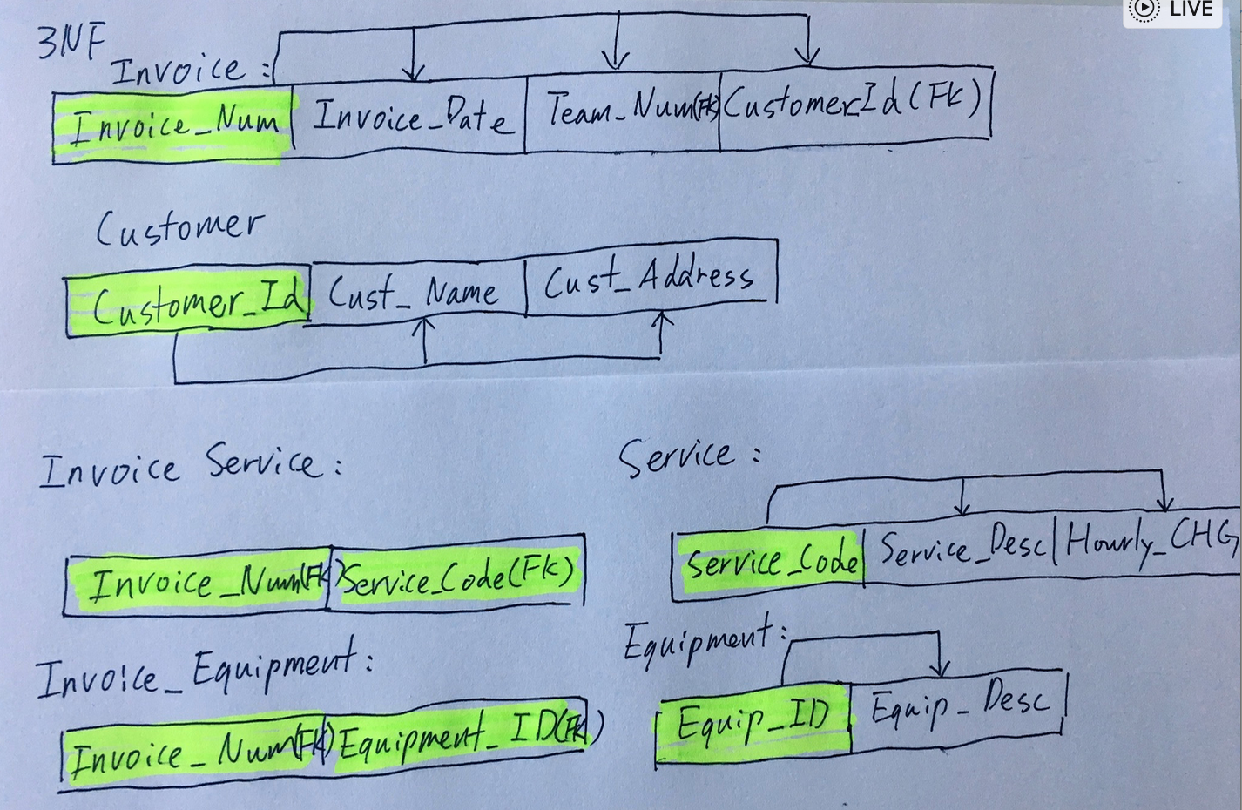

(Invoice Number, Service Code)

**Invoice:**Invoice_Number -> Invoice_date, Team_Num, Customer_Id(FK)

**Customer:**Customer_Id->Customer_Address, Customer_Name

**Invoice Service:**(Invoice Number, Service Code(FK))

**Service:(**Service_Code-> Service_Description**)**

**Invoice Equipment:(**Invoice_Number, Equipment_Id

**Equipment:**Equipment_Id -> Equipment_Description

**User View 2:**

**Normalization**

**UNF**

Team_Num, Employee ID → Team’s Description, Name, Position, OHIP_ Num, Home_Phone, Start_Date, Skills

**1NF**

**TEAM_EMPLOYEE:**Team_Num, Employee_ID → Team’s Description, Name, Position, OHIP_Num, Home_Phone, Start_Date, Skills

**Partial dependencies:**

Employe_ID -> Name, Position, OHIP_Num, Home_Phone, Start_Date, Skills Team_Num-> Team_Description

**2NF**

**TEAM_EMPLOYEE:** Team_Num(FK), Employee_ID(FK)

**TEAM:** Team_Num->Team_Description

**EMPLOYEE:** Employee_ID->Name, Position, OHIP_Num, Home_Phone, Start_Date, Skills

**3NF**

Same as 2NF

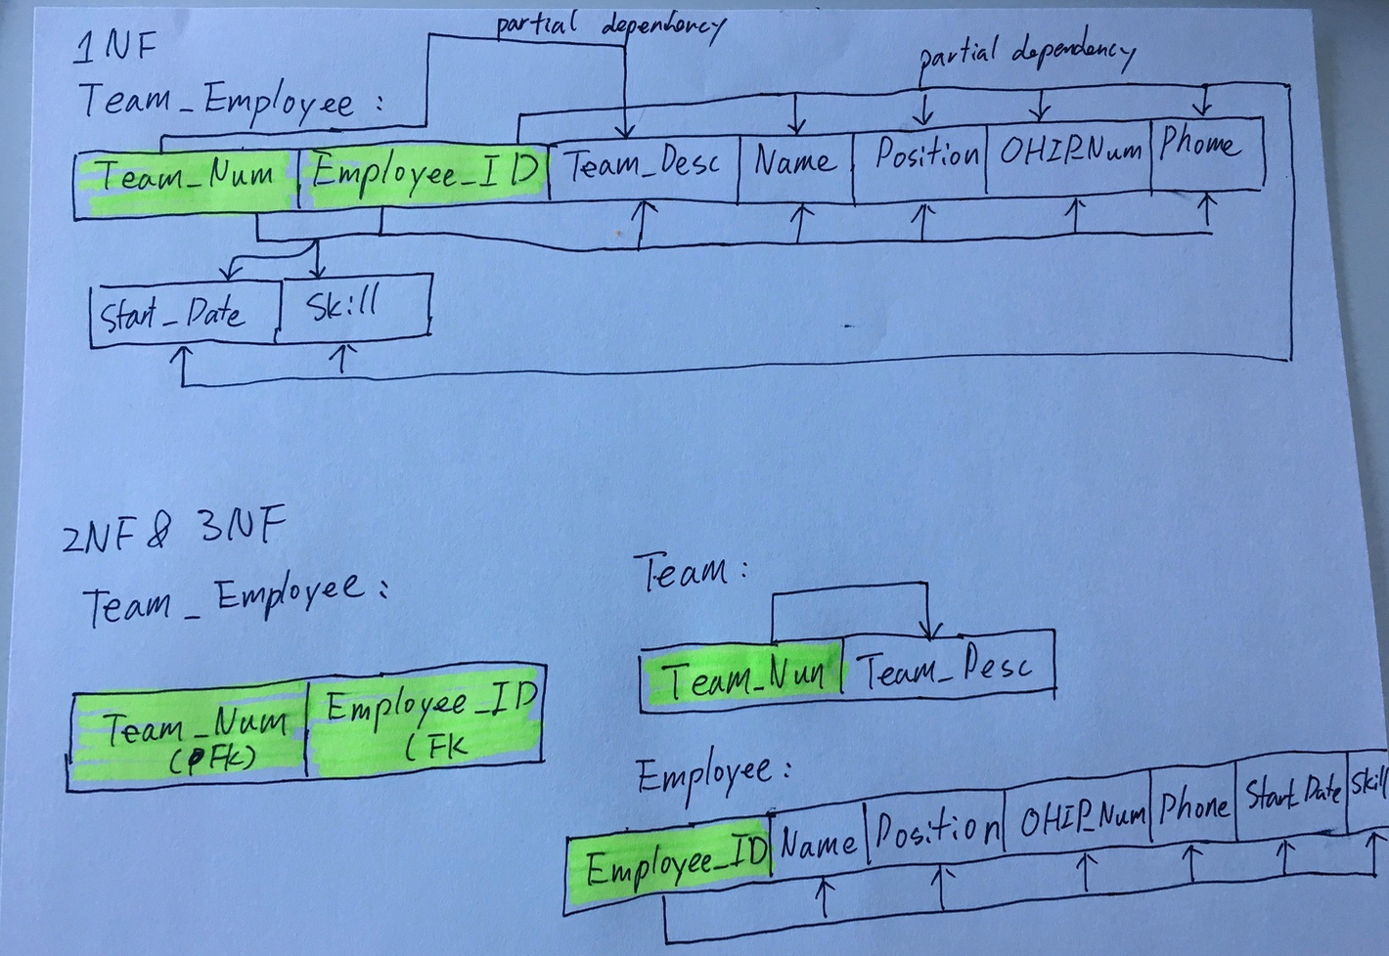

**User View 3:**

**UNF**

PROD ID, INVOICE ID -> PROD CLASS, PRODUCT, CHARGE, SALES ASSISTANT, INVOICE DATE, CUST NO., QTY.

**1NF**

**PRODUCT_REPORT**:

PROD ID, INVOICE ID -> PROD CLASS, PRODUCT_DESC, CHARGE, SALES_ASSISTANT, INVOICE DATE, CUST NO, QTY.

**Partial Dependencies:**

PRODUC_ID->PRODUCT_CLASS,PRODUCT_DESC,CHARGE

INVOICE_ID->SALES_ASSISTANT, INVOICE DATE, CUST_NO, SALES_ASSISTANT

**2NF & 3NF**

**PRODUCT_REPORT:**

PROD ID, INVOICE ID -> QTY

**PRODUCT:**

PROD ID -> PROD CLASS, PRODUCT_DESC, CHARGE

**INVOICE:**

INVOICE ID-> INVOICE DATE, CUST NO, ,SALES ASSISTANT

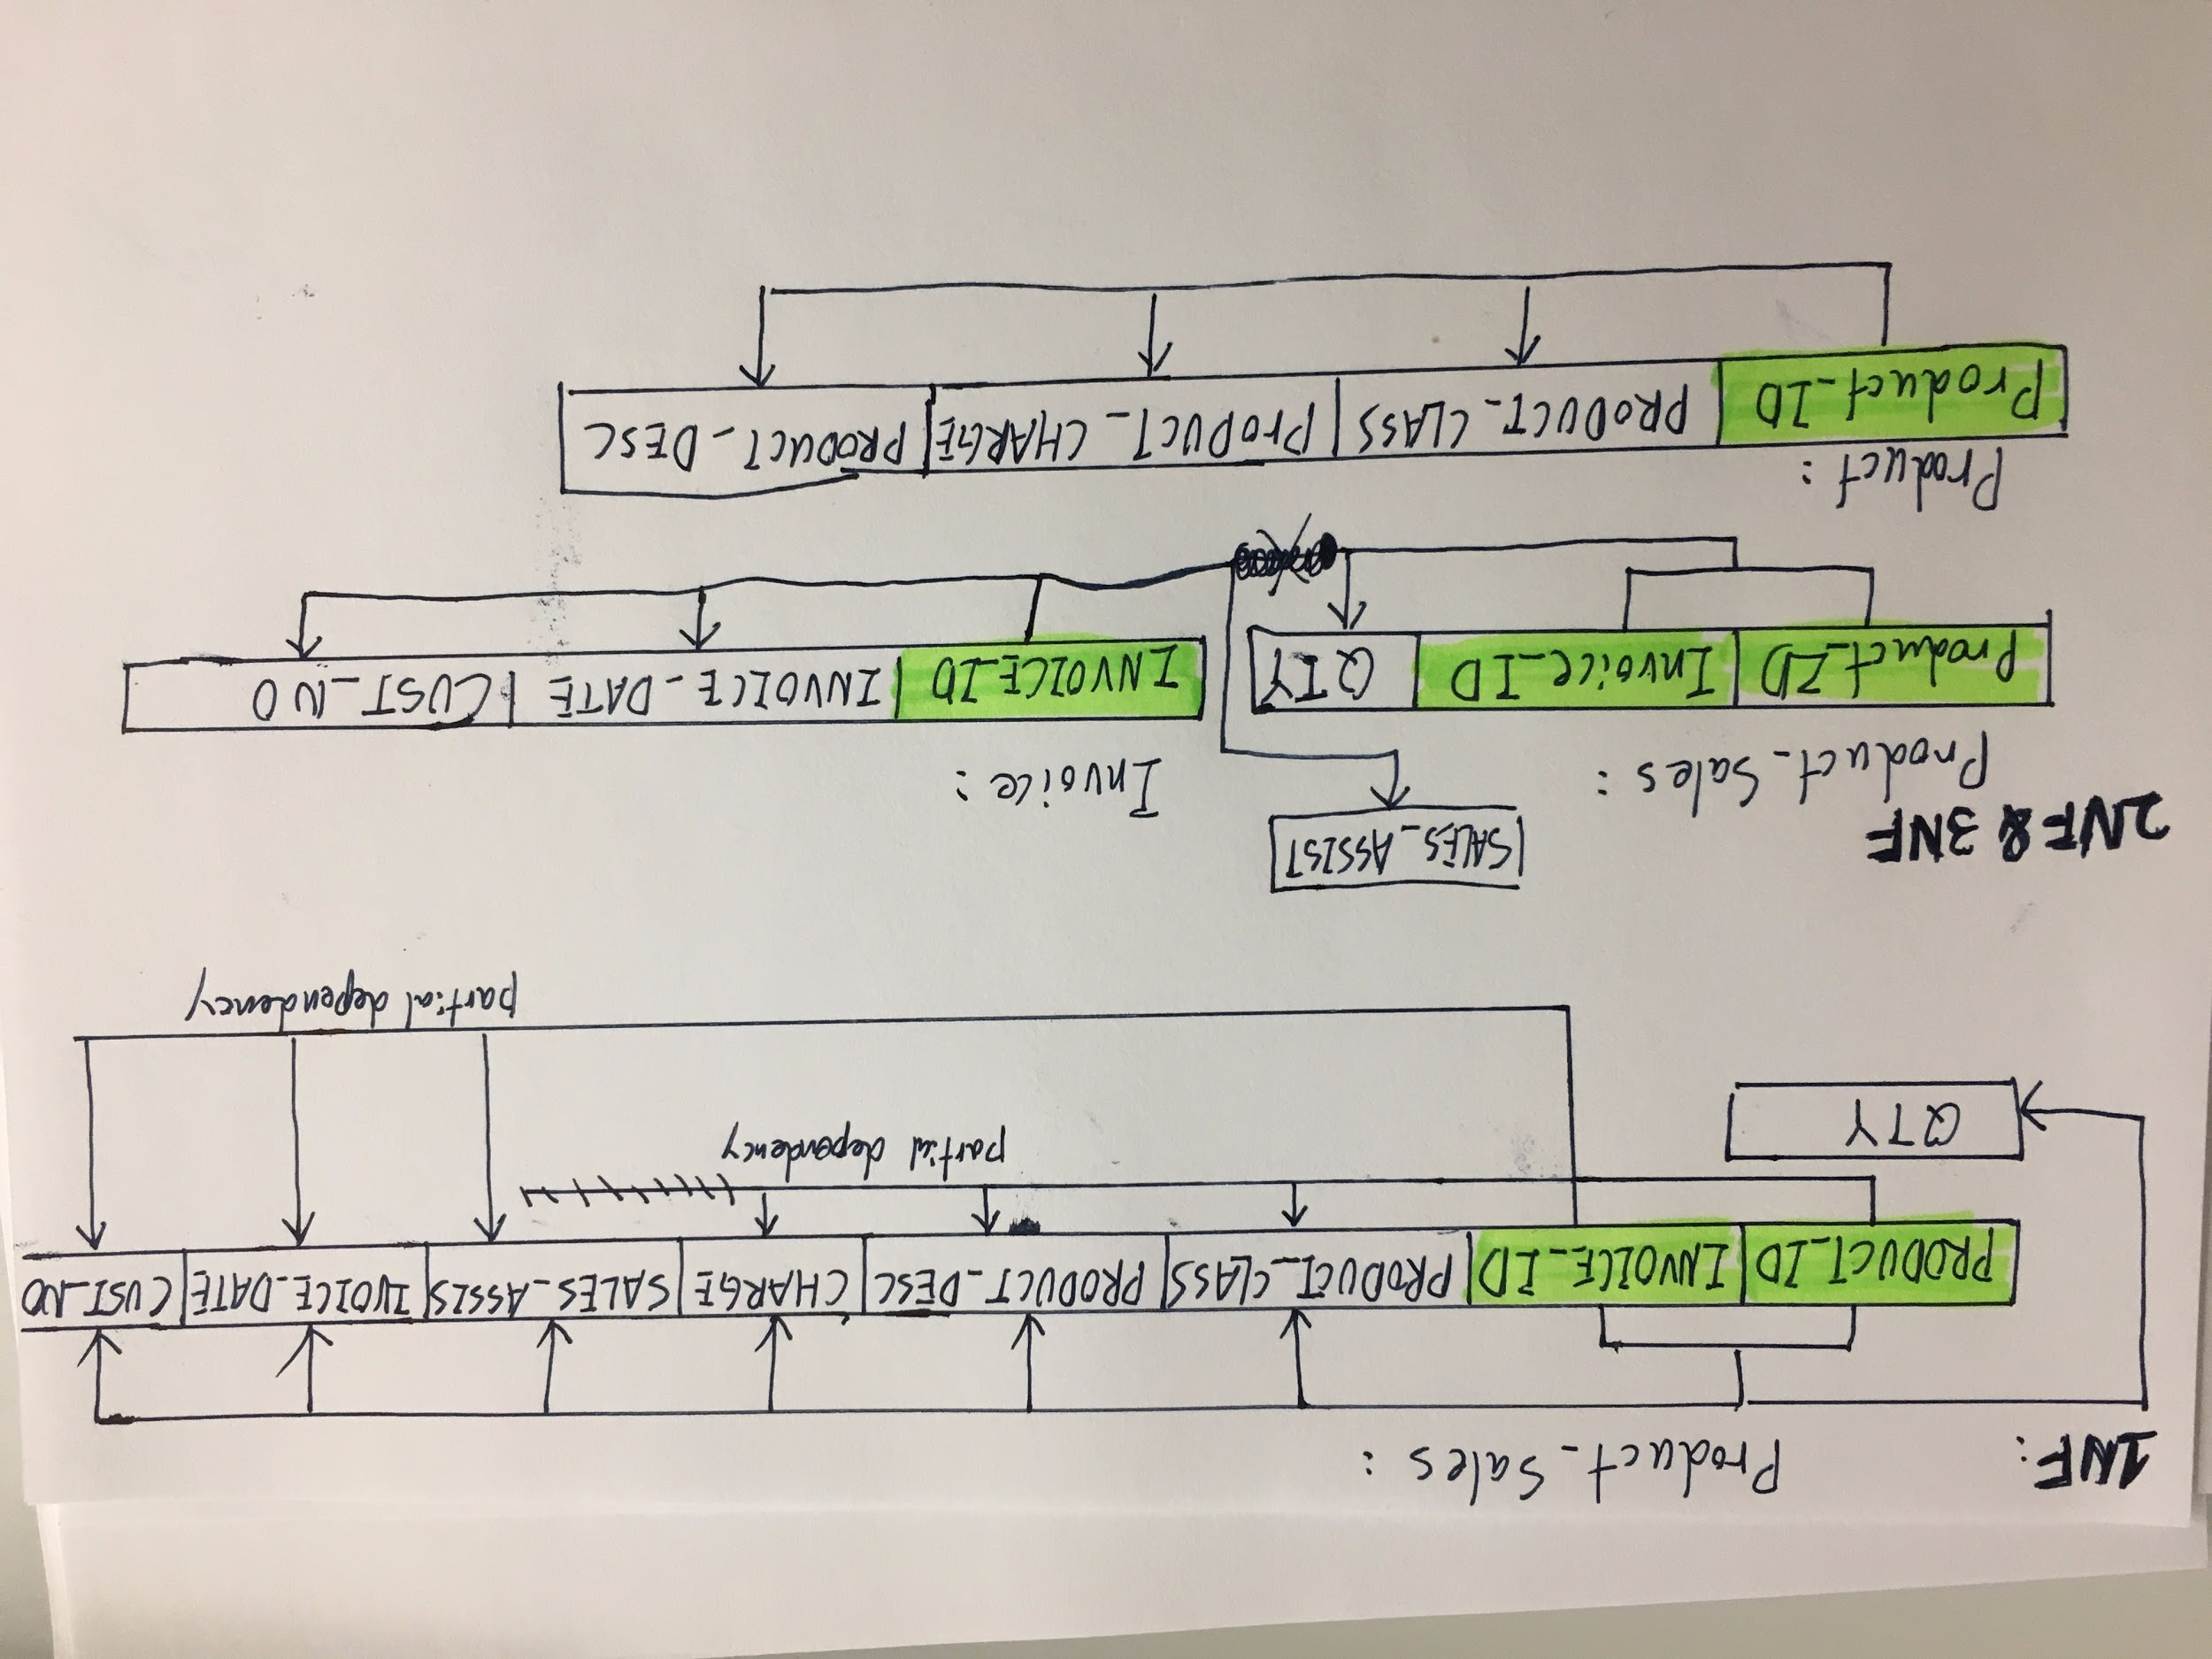

**User View 4:**

**UNF**

PRODUCT ID -> MARKUP, PRODUCT CLASS, CLASSIFICATION, DESCRIPTION, COST, CHARGE.

**Partial Dependencies:**

PRODUCT CLASS -> CLASSIFICATION, MARKUP.

**1NF**

PRODUCT ID -> MARKUP, PRODUCT CLASS, CLASSIFICATION, DESCRIPTION, COST

**2NF**

PRODUCT ID -> MARKUP, PRODUCT CLASS, CLASSIFICATION, DESCRIPTION, COST,

**3NF**

PRODUCT ID -> PRODUCT CLASS, DESCRIPTION, COST.

PRODUCT CLASS -> CLASSIFICATION, MARKUP.

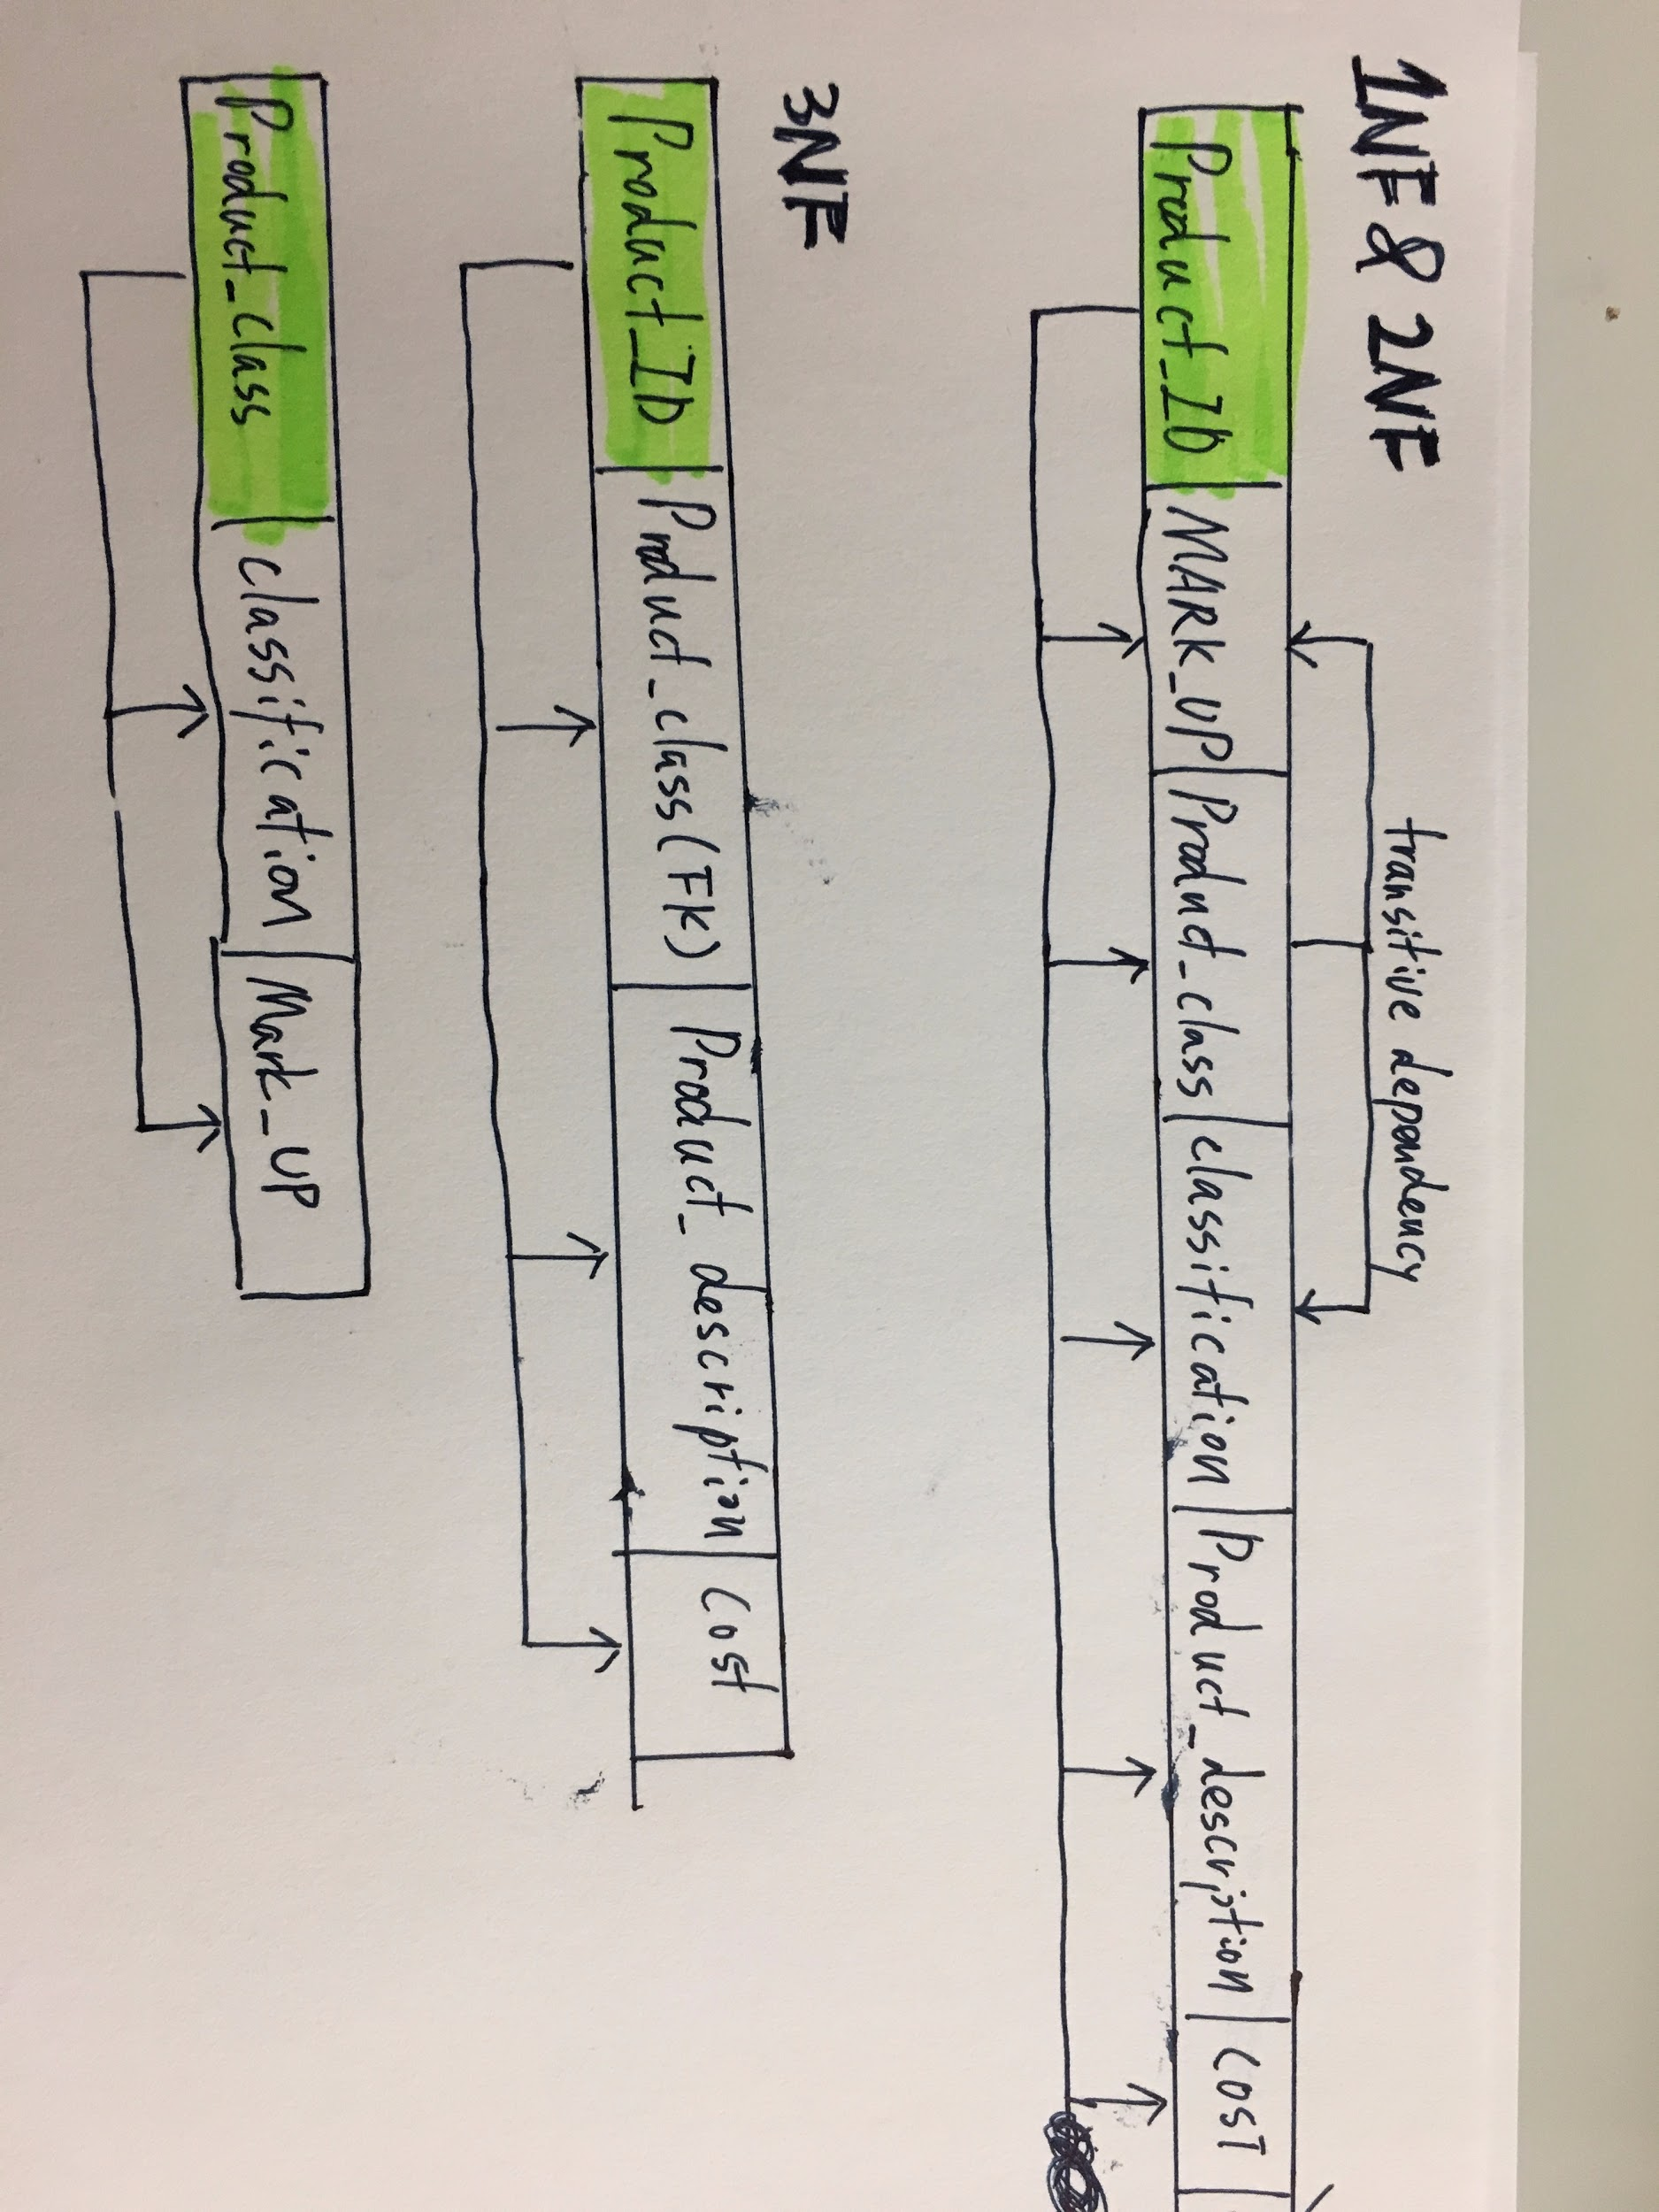

**User View 5:**

**1NF :**

PRODUCT_ID ->PRODUCT_DESC, PRODUCT_INV, AISLE_NUM, SUPPLIER,

**2NF:**

PRODUCT_ID -> PRODUCT_DESC, PRODUCT_INV, AISLE_NUM, SUPPLIER

**3NF:**

PRODUCT_ID -> PRODUCT_DESC, PRODUCT_INV, AISLE_NUM, SUPPLIER

